r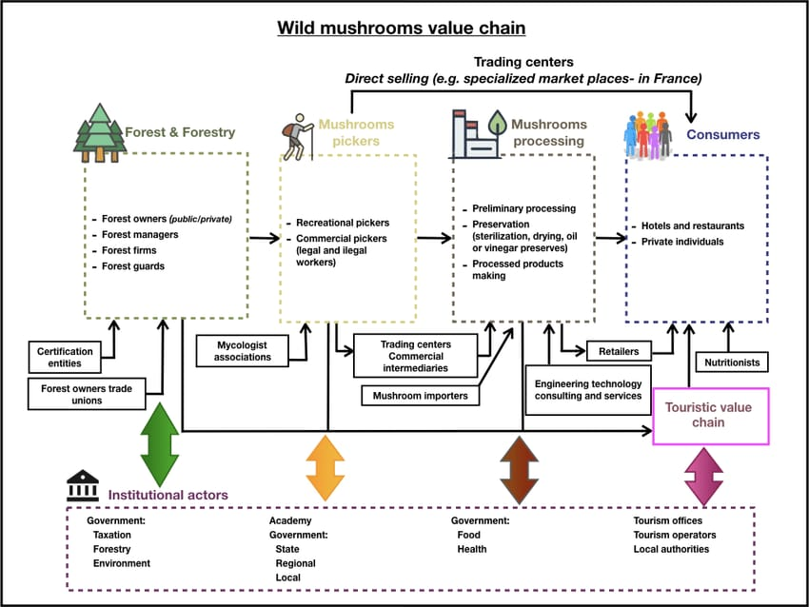

Reference Link: <https://www.researchgate.net/figure/Wild-mushrooms-value-chain-map-resulted-from-the-scoping-seminar_fig4_358798343>